Calvert Green - New NEAP
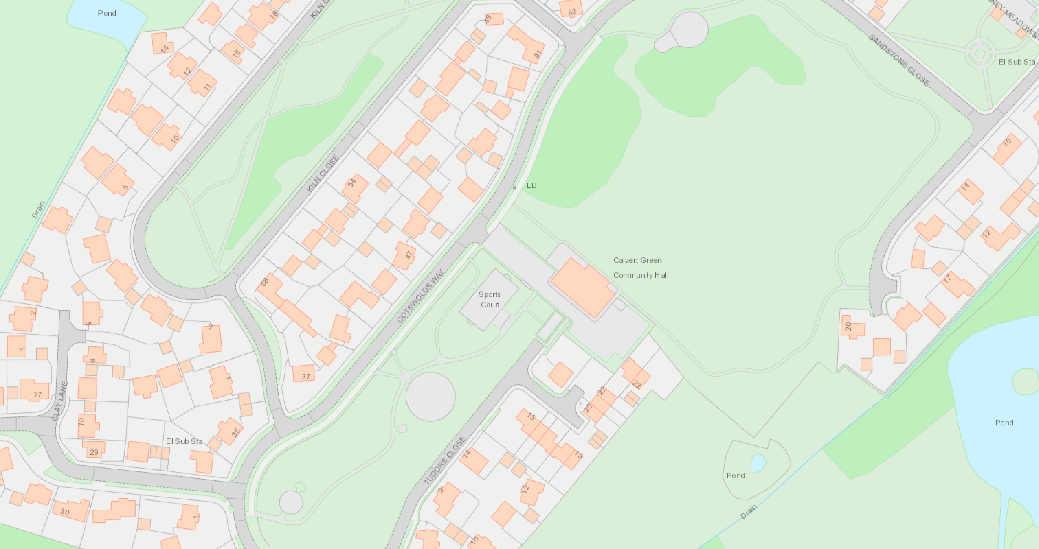
3
2
1
Toddler
Toddler/Junior
Junior/Teen
New Path

